Assessment 3: Governance and Stewardship Paper
Student Name:
Student ID:
Word Count: 2500
Reference: APA

Table of Contents
Introduction 3
Discussion of key theories of governance that have contributed to organizational effectiveness in general 4
Contributions of Stewardship Theory in general to effective management in non-profit and for-profit organizations 8
Discussion of the relationship of a leader’s values and beliefs to effective governance in organizations 11
Conclusion 14
Reference 15

Introduction
The concept of governance can be better known as standard norms and regulations in society for public awareness and social being. In other words, the governance of a country depends on the government and its board of members or associations together taking equal participation in the decision-making process for the strategic management of a nation. Besides, stewardship is a notion of protecting human assets and accountabilities for future prospects. In fact, the act of steward is also to administer and organize something delegated to one’s concern. The assignment will throw an in-depth discussion and analysis of theories of governance and its usefulness for the organisation. Further, it will focus on the involvement of stewardship theory for robust governance in profit and non-profit organisations. In addition to this, the assessment will emphasize the relationship of leaders' values and beliefs in disciplined supremacy of organisations.

Discussion of key theories of governance that have contributed to organizational effectiveness in general
Theories of governance are significant in terms of ethical regulation of policies and securing valuable assets of organisations. There are number of methods of which three specific has been illustrated below:-
Agency Theory: According to the agency theory, the shareholders hand over the right of business operations to the agents (Bendickson et al., 2016). In other words, the agents are none other than the top-level members of an organisation. Below is the diagrammatic figure of agency theory highlighting the process of workflow:-
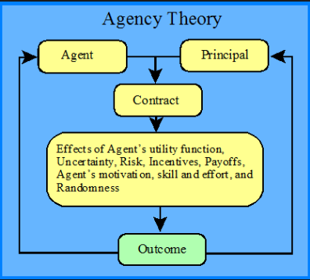
Figure 1: Model of Agency Theory of Governance
(Source: Bosse & Phillips, 2016)
The following diagram provides a strategic flow of an implementation of a business plan of action. The agent in the figure signifies the Board of Directors or the Senior Managers, especially the CEO of companies. The primary aim of agency theory enables the shareholders to hire the agents, as mentioned above of an organisation to take the best possible responsibility of a business in terms of decisions and management of an organisation. However, it is not obligatory for agents to obtain the best concern of the shareholders. The agents are surrendered to, and opportunistic behaviour often tends to fall short of the probability of the shareholders. From the analysis of the theory, it can be understood that it works resourcefully with the division of ownership and control, respectively. The agency theory is useful in managing supply chain checkpoints of an organisation that impels employees to engage in work process dedicatedly (Bosse & Phillips, 2016). For example, in case of a transportation organisation, it is essential for the agents to give instructions to the executives taking the initiative in auditing the long route trucks or Lorries at the checkpoints to avoid any financial losses for any issues and deliver the goods and raw materials to the proper destination within the time frame. From this example, it can be assumed that agency theory is quite influential and constructive in nature. In addition, it is beneficial for employees in developing their skills and competencies for being more accountable and responsible in their individual tasks provided by the managers. Moreover, agency theory is applicable for reward and reprimand for the purpose of rectification of agents’ precedence.
Stakeholder Theory: The stakeholder theory is an establishment for enhancing the management of an organisation extensively by maintaining equal rights and opportunities of the managers and the associated stakeholders. Below is the figurative presentation of the workflow of stakeholders' contribution to an organisation:-
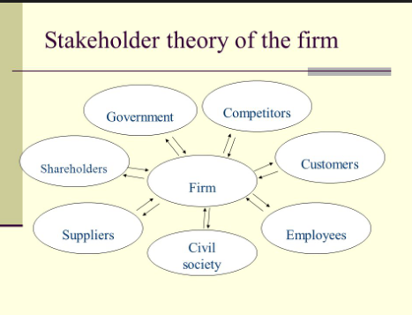
Figure 2: Model of Stakeholder Theory of governance
(Source: Miles, 2017)
From the diagram, it signifies that for an organisational context the decision-making process of managers in the top-level management includes similar interests and priorities of all stakeholders with an inherent value without supremacy on others (Miles, 2017). The role of government with an organisation is to monitor and ensure the correct execution of business and ethical code of practices, which are appropriately maintained by the management. On the other hand, the shareholders are principals of a firm having share and interests from the owners of a business. Besides, the suppliers are indirectly associated with a firm being an effective resource for strengthening the channels of supply and logistics of products and services (Ketokivi & Mahoney, 2016). Besides, the customers are the fundamental stakeholder for whom organisations run successfully in a specific market. Further, the employees are the assets and strengths for executing operations and management for output and prosperity. However, the civil society and the competitors are external stakeholders having high interests with a firm but least share in the business. For instance, without the engagement and contribution of a single member, an organisation is unable to stabilise its infrastructure of business in an appropriate direction. Hence, it can be understood that the accumulation of all the stakeholders together makes value and establish a brand image in a country.
Resource Dependency Theory: The resource dependency theory is beneficial for an organization in finding essential resources suitable for the functions of the business. The diagrammatic presentation helps in illustrating the rationale of the theory:-
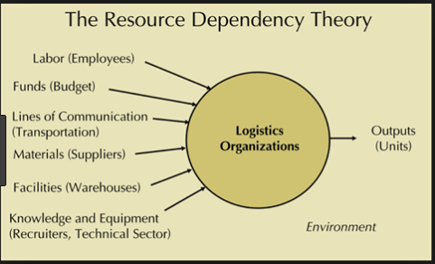
Figure 3: Resource Dependency Theory of Governance
(Source: Brown & Pappous, 2018)
Based on the above figure, the resource dependency theory can be applied in every form of business. According to the theory, the Board of Directors are superior levels belongs to the management of an organization accessing external environment of business for collecting a number of key resources and securing them for driving it into the functioning process (Brown & Pappous, 2018). It tries to depict that the directors of organizations are the primary medium of communicating with outer sources and channels such as information and valuable stakeholders like suppliers, special interest groups like public policy makers, buyers and financial investors as well. These are basic ingredients of business necessary for running an organization and surviving in a market for long-long years. The ultimate understanding of the theoretical concept is that without adequate resources of materials and products, an organization is unable to withstand in the broader market. Moreover, it also cannot be possible to gain a competitive advantage from rivals. For instance, if a single resource such as lack of types of equipment or line of communication like transport is missing, then a firm might be troubled intensely for having efficient support of the technical team for controlling and managing the recruitment process. Similarly, the absence of a proper communication channel, it would not be possible for a production team to deliver the ordered products to the customers on time. Therefore, resource dependency theory is applicable as one of the governance theories for sustaining effortless work process of organizations worldwide.

Contributions of Stewardship Theory in general to effective governance in non-profit and for-profit organizations
Concept of Stewardship Theory:
The stewardship theory can be defined as an individual working as stewards on behalf of an owner leading with the capability and power of a quasi-ownership attempt in a business (Glinkowska & Kaczmarek, 2015). In other words, a steward is a simple executive or an employee of an organisation, or it can be a manager of middle-level management protecting for the purpose of a company's profit and creating value to the customers. The concept of stewardship theory can be shown through the figurative view below:-

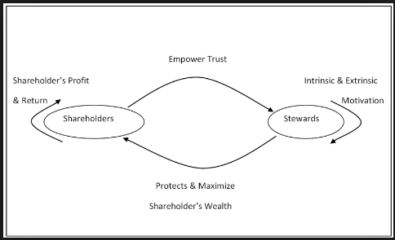
Figure 4: Stewardship Theory of Governance
(Source: Glinkowska & Kaczmarek, 2015)
From the figure, it can be deduced the entire process of responsibilities performed by a steward in an organization for gaining excellence and sustainability in business. In other words, the employees assigned for a designation of an executive or sales are stewards hired in an organization with specific job roles and responsibilities in achieving goals and objectives set by the shareholders (Andrei, Balluchi & Furlotti, 2018). In fact, a Steward is competent enough to protect and maximize the wealth of the shareholders and in return, attains maximum benefits in the form of rewards or incentives or increases shareholders’ profit. This, in turn, motivates Stewards and builds trust with the shareholders for continuing the functions of business in a strategic process. It can be understood that for any type of organizations, the function of a steward is enforced by law and ethical, as the theory justifies the entire functions and accountability of an efficient Steward.
For-Profit Organizations, a steward act as an active expert in handling and operating entire business functions are tactically managed and monitored with proper supervision for attaining sustainability (Rana et al., 2018). It can be understood that in a profit organization, Stewards act according to the mission and vision statement of the organization and set targets for achieving organizational objectives. For example, the departmental managers like a Retail manager or Sales manager controls and intervene the activities of the junior staffs under them and check efficiently whether the production process is going on, as per the strategic directions and policies prescribed by the Directors of the organization. Similarly, the team leaders or the supervisors allocated for the proper intervention of the supply chain network is scrutinized for maintaining active logistics management. On the other hand, stewards like marketing executives are another skilled expert for research and development of a suitable market decided by the top-level organizer or managers to expanding a business or opening a new business as well. Such expertise helps a profit organization to identify the risks and possible barriers in the external business environment and further propose a strategic marketing plan forwarding it to the Directors to take final decisions. This process of maintaining the business process actively taking the desired responsibilities in hand by the respective stewards makes a profit organization gain competence and prosperity and increase value to the customers in a society.
On the other hand, for Non-Profit Organizations, the Stewards act in a different way in the form of a Volunteer or a Social Activitist for the sake of social benefit itself. In other words, the stewards act autonomously for creating value and recognition in a society (Andrei, Balluchi & Furlotti, 2018). For non-profit organizations, the stewards can be the working agents or volunteers or the charitable trust involved deeply with the social concern. It tries to determine the fact that the members of non-profit organizations usually act conscientiously for saving the lives of the poor and backward class of people with prompt actions and medical aids provided within the scheduled time frame. For example, in a non-profit organization, the public fund organizer or the Chairperson or even the Board of members assimilated to raise funds for any social cause for either children’s education or nutrition are independent players in the field for successfully benefitting society at large scale. Similarly, the marketing executives working in the non-profit firms are taking initiatives in visiting places in finding adequate resources and information for exploring the truth to the society are active stewards as well. Other than this, the stewards like executive Directors are involved in finding better tools and techniques for improving the strategic flow of work at higher levels. Therefore, managing a wide range of resources like people, funds and environment at the same time are only possible by adapting to the strategic theory of stewardship. Hence, it can be ensured that stewardship theory is also equally applicable for non-profit organizations in receiving worldwide recognition and honor than earning a profit.

Discussion of the relationship of a leader’s values and beliefs to effective governance in organizations
A leader's values and beliefs are considered to be assets for organisational growth and development. In other words, the leadership approach in an organisation is to improve the organisation's performance levels and reinforcement of the workforce (O’Connell, 2016). It demonstrates the fact that a leader is an individual according to whom; employees are compiled to act and develop their abilities for the purpose of acquiring gratitude and value. This can be possible through underlying managers’ contribution as well in strategic course and instructions taken from the leader and implementing it into systematic transformation. It can be better understood from different perspectives of leaders:-
Leaders’ perspectives for motivating employees: Leaders are generally active from the beginning with natural in build features. In fact, the perception of a leader to motivate people can influence them to work with satisfaction (Higgs & Dulewicz, 2016). It means that if a leader's beliefs and values are genuinely compassionate towards people, then the intention of such a leader would always effort to make a healthy environment for staffs in an organisation. This would provide the employees' motivation from the learning experience and training facilities and skill development for using useful tools and techniques for organisational effectiveness at the end. For instance, if employees are not given inspiration at work, then they tend to feel disappointed from work and are compelled to discontinue the job at the end of the day. As a result, most of the organisations face similar situations for losing a number of employees and the falling shortage of human resources at work. In order to manage administration in the right way, a good leader is always accurate and the leadership skills, values and beliefs are influential behind the decision-making process. Hence, it determines the fact that the leader's values and beliefs are deeply associated with effective governance and control over subordinates with equal priority.
Leaders’ beliefs in diversity management: On the other hand, a good leader would need to address issues of diversity management in an organisation. In other words, organisational growth and culture are managed through the strategic discharge of policies for creating unity at work (Gotsis & Grimani, 2016). It consciously affirms that diversity is an aspect of effective leadership approach in sustaining a workforce of an organisation intact. For example, if there is an issue of conflict between the cross-functional team, then it can be addressed intelligently with knowledge and experience by a proficient leader and impart planned policy and norms that are liable to be accepted by employees. Thus, the issues among employees would be reduced through various ways of employee engagement programs or involvement in compliance with the regulation of government norms. Therefore, this process can be termed as one of the corporate governance ability generated for employees to avoid conflicts and accepts inequality with respect and dignity. Hence, it shows another deeper relationship between a leader's values and beliefs with organisational effectiveness.
Leaders’ perception of effective teamwork: Other than this, a leader’s values and beliefs are related to the organisational effectiveness in terms of building effective teamwork. The teamwork of an organisation can be strengthened by an intended management and disciplinary action plans and logical way of solving problems by an admirable leader (Gebert, Heinitz & Buengeler, 2016). It delineates the fact that is a leader's values, and beliefs seem to be positively driving workforce towards commitment and acting as a team then it would be advantageous for an organisation to achieve success, glory and value to the customers. For instance, an effective leader is supposed to solve the problems of a team member through interaction regularly for finding the cause of conflicts and act as a good listener first. This intends to guide a leader to evaluate a problem with the right intrusion and suggest an appropriate solution at the end. Hence, this kind of nature is often seen in a leader of an organisation who is deemed as the Directors and the CEOs of small to medium and large organisations. Therefore, the beliefs and values of such leaders are in deep relationship with the organisation's performance and output.

Conclusion
From the overall analysis of the assessment of governance and stewardship, it can be understood that both are interrelated with each other and most prominently stewardship theory is part of governance that has the capacity to control and manage operations and management of an organisation resourcefully. In other words, the leader's values and beliefs are the active components that enforce actions and decision-making process to be taken logically, as per situation and benefit of all stakeholders associated with an organisation. Therefore, it helps in establishing a sustainable organisation in a society.

